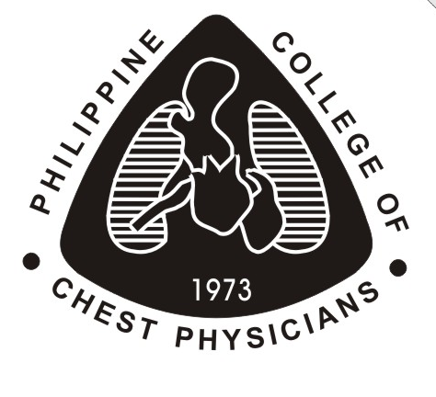 | PHILIPPINE COLLEGE OF CHEST PHYSICIANS  Advancing the Frontiers of Pulmonary Medicine in the Philippines.

APPLICATION FORM FOR
DIPLOMATE CERTIFYING EXAMINATION

LAST NAME | FIRST NAME |  | MI
BIRTHDATE (mm/dd/yyyy) | CONTACT INFO FOR PCCP’s REFERENCE:  CELFONE NO. | E-MAIL ADDRESS
POSTAL MAILING ADDRESS (Residential/Clinic)  _________________________________________________________________________  _________________________________________________________________________  _________________________________________________________________________  ________________________________________________________ZIP CODE ________ |  | TRAINING INSTITUTION (GRADUATED FROM)
HOSPITAL AFFILIATION/S  - ___________________________________________________________________  - ___________________________________________________________________  - ___________________________________________________________________ |  | BUSINESS PHONE  - _______________________________  - _______________________________  - _______________________________

______________________________ _________________
APPLICANT’S SIGNATURE DATE

======================================================================
FOR PCCP USE ONLY

Date Submitted __________________OR No. _______________ Received by:__________________

Requirements presented:

  - Must be a member of the Philippine Medical Association.
  - Certificate attesting to being a diplomate of good standing of the Philippine College of Physicians.
  - Certificate of completion of fellowship (Diploma) in a PCCP accredited pulmonary fellowship training program. For applicants who graduated before year 2022, certification from the Section/Department Head will be accepted.
  - Submit copy of completed research paper as required in the Standards and Requirements for Accreditation of Adult Pulmonary Medicine Fellowship Training Programs in the Philippines (April 2022); the applicant shall also submit copy of acknowledgment receipt from the Phil J of Chest Diseases editorial staff. (see OBE Curriculum 2022; XI. Research as Teaching-Learning Activity, No. 2)
  - Checklist summary of requirements for each Fellow-in-Training certified by the Training Officer

